Measurement Protocol PAX

# General Information:

|  |  |  |
| --- | --- | --- |
| Test date: 09/11/19 | Date prev. test: NA | Test number: 1 |
| Tested by: Alex Pollak | PAX number: PB-037 | Installed at ant.: NA |
| Comments: X-Pol has a higher gain than the Y-Pol, hence detector value should be set to a | | |
| lower value in order to have the same output power. | | |
|  | | |
|  | | |
| Known problems: Fiber connector X pol had a problem and has been replaced. | | |
| . | | |
|  | | |
|  | | |

# Setup:

|  |  |  |  |
| --- | --- | --- | --- |
| Power supply: | OK 🗹 NOK 🗆 | Communication: | OK 🗹 NOK 🗆 |
| Supply current +6V: 1.126mA | | ssh obs@antcntl | |
| Supply current -6V: 0.110mA | | ssh ataant@ant0 | pw: q@n@t |
| Supply current +5V: 0.040mA | | telnet pax | “help” |
|  | | CTRL + ] | “close” |

# RF Test with VNA:

### VNA Setup:

|  |  |  |
| --- | --- | --- |
| Load configuration: Passband_PAX.csa | | |
| Freq Start: 1.0 GHz | Freq Stop: 13.0 GHz | Power Level: -20 dBm |
| Averaging: enabled | Averaging count: 15 | N. Points: 801 |
| VNA : Agilent N5230C 10MHz - 20GHz | | |

|  |  |  |  |  |
| --- | --- | --- | --- | --- |
| VNA to PAX connection: | 1m ABC-CA18 Cable + 20dB Attenuator | | | |
| Input Power Level to PAX: (Measured) | @1GHz:  -40.2dBm | @4GHz:  -40.7dBm | @8GHz: -41.2dBm | @12GHz: -41.4dBm |

|  |  |
| --- | --- |
| PAX to VNA connection: | 2m Fibre Cable + Fibre Diode + AOX Amplifier + 1m ABC-CA18 Cable |

### Measured Passband with Attenuator set to 7dB each (Complete Link):

|  |
| --- |
| X |

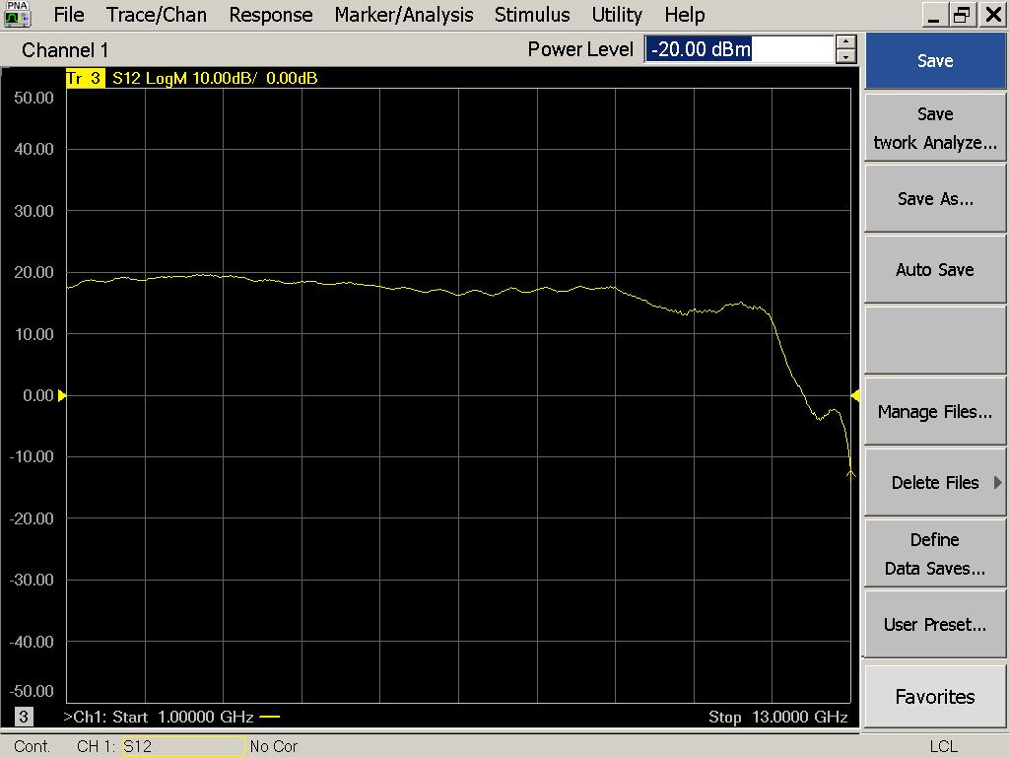

|  |  |  |  |
| --- | --- | --- | --- |
| Flatness: | OK 🗹 NOK 🗆 | Unwanted Features: | Yes 🗆 No 🗹 |

|  |
| --- |
| Y |

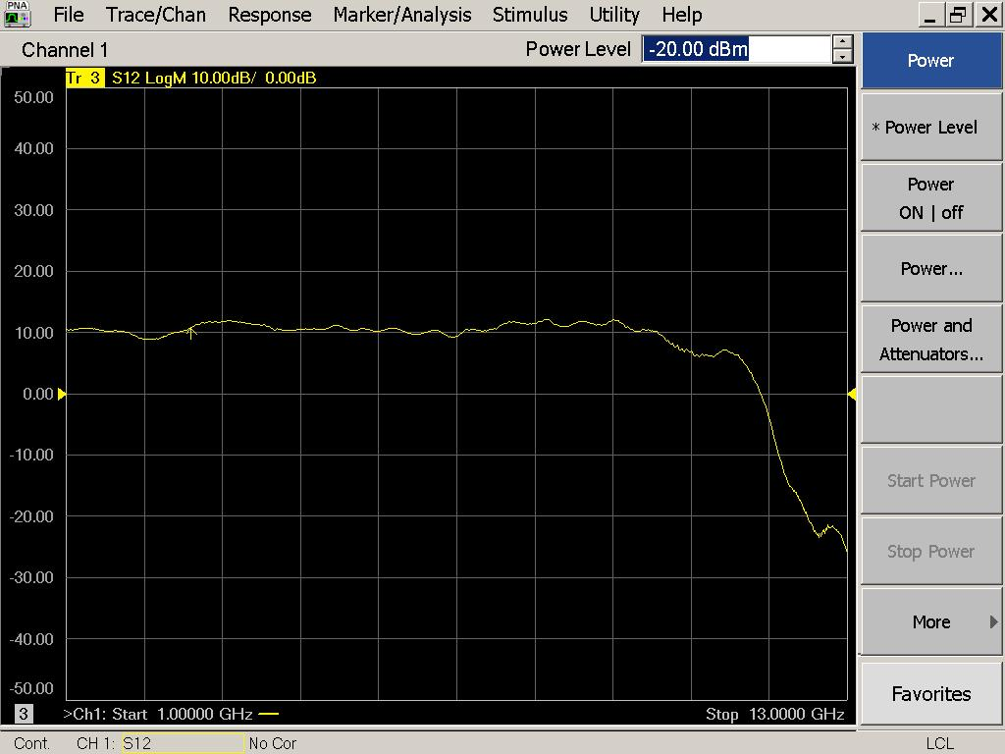

|  |  |  |  |
| --- | --- | --- | --- |
| Flatness: | OK 🗹 NOK 🗆 | Unwanted Features: | Yes 🗆 No 🗹 |

### Power Sweep (Complete Link):

|  |  |  |
| --- | --- | --- |
| Load configuration: Power_Sweep_PAX.csa | | |
| Power Start: -40dBm | Power Stop: -20dBm | Frequency : 4.0GHz |
| PAM Attenuator: 0dB |  | N. Points: 801 |

|  |
| --- |
| X |

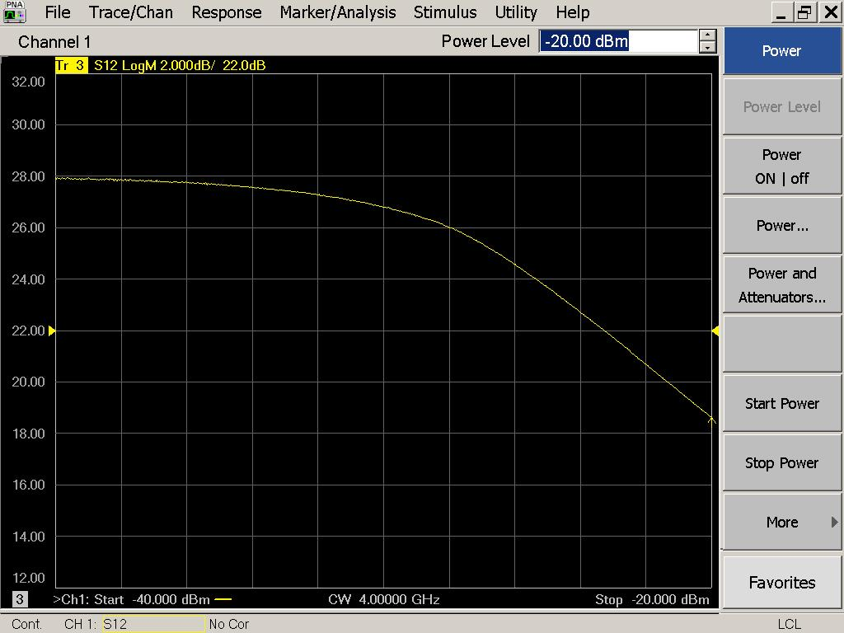

|  |  |  |  |
| --- | --- | --- | --- |
| Compression point: | OK 🗹 NOK 🗆 | Unwanted Features: | Yes 🗆 No 🗹 |

|  |
| --- |
| Y |

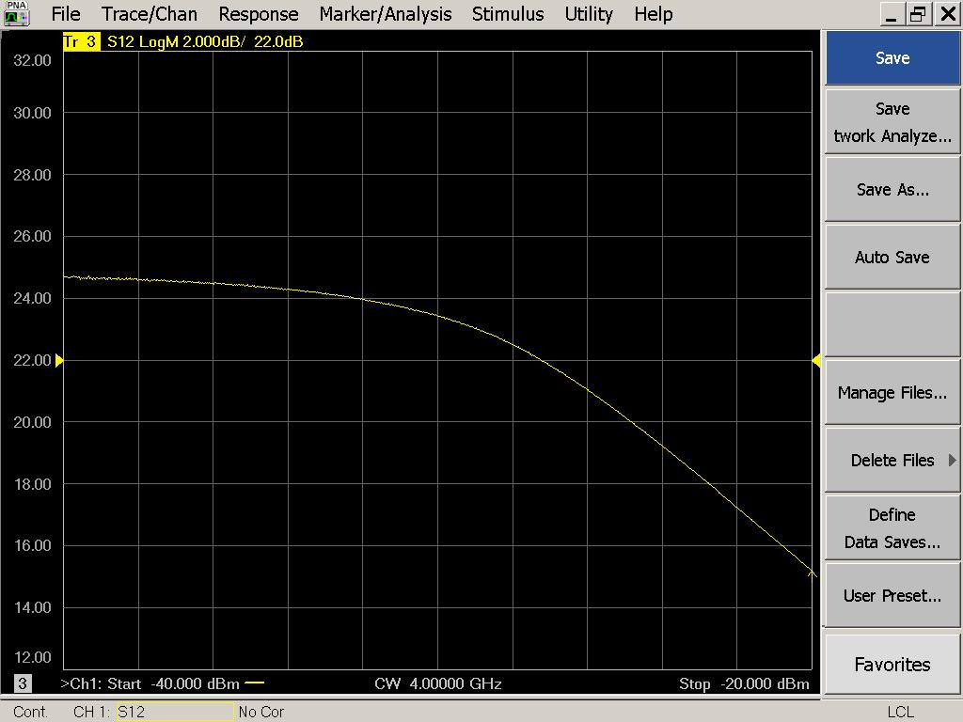

|  |  |  |  |
| --- | --- | --- | --- |
| Compression point: | OK 🗹 NOK 🗆 | Unwanted Features: | Yes 🗆 No 🗹 |

### Detector Calibration and Attenuator Sweep Pol X:

|  |  |  |
| --- | --- | --- |
| Load configuration: Detector_Calibration_PAX.csa | | |
| Freq : 4.0 GHz | Power Level: -20dBm | Sweep Time: -20sec |
| Sweep Mode: CW | Power Level at PAX Input (Measured): -40.6dBm | |

|  |  |  |  |  |
| --- | --- | --- | --- | --- |
| X | | | | |
| CW Input Power [dBm]: | Attenuator Value A [dB]: | Attenuator Value: B [dB]: | Detector Value: | Power Meter  Value [dBm]: |
| -40.6 | 0 | 0 | - | 13.06 |
| -40.6 | 0 | 3 | - | 13.20 |
| -40.6 | 0 | 6 | - | 12.89 |
| -40.6 | 0 | 9 | - | 10.73 |
| -40.6 | 0 | 12 | 0.8475 | 7.76 |
| -40.6 | 0 | 15 | 0.7108 | 5.00 |
| -40.6 | 0 | 18 | 0.3853 | 1.70 |
| -40.6 | 0 | 21 | 0.2108 | -1.33 |
| -40.6 | 3 | 21 | 0.1026 | -4.77 |
| -40.6 | 6 | 21 | 0.0537 | -7.75 |
| -40.6 | 9 | 21 | 0.0277 | -10.78 |
| -40.6 | 12 | 21 | 0.0147 | -13.76 |
| -40.6 | 15 | 21 | 0.0079 | -16.70 |
| -40.6 | 18 | 21 | 0.0043 | -19.97 |
| -40.6 | 21 | 21 | 0.0027 | -23.04 |
| -40.6 | 24 | 21 | 0.0019 | -25.88 |
| -40.6 | 27 | 21 | 0.0015 | -28.92 |
| -40.6 | 30 | 21 | 0.0013 | -32.05 |
| -40.6 | 30 | 24 | 0.0012 | -34.67 |
| -40.6 | 30 | 27 | 0.0011 | -37.08 |
| -40.6 | 30 | 30 | 0.0011 | -39.33 |

|  |  |  |
| --- | --- | --- |
| Use Noise Source: Atlantic AS6333 | | |
| Freq : 1.0 - 12.0GHz | Power Level: -41.8dBm |  |
| DC Supply: 28V |  | |

|  |  |  |  |  |
| --- | --- | --- | --- | --- |
| X | | | | |
| CW Input Power [dBm]: | Attenuator Value A [dB]: | Attenuator Value: B [dB]: | Detector Value: | Power Meter  Value [dBm]: |
| -41.8 | 0 | 0 | - | 11.87 |
| -41.8 | 0 | 3 | - | 11.19 |
| -41.8 | 0 | 6 | - | 10.04 |
| -41.8 | 0 | 9 | - | 8.38 |
| -41.8 | 0 | 12 | 0.8475 | 5.97 |
| -41.8 | 0 | 15 | 0.5629 | 3.64 |
| -41.8 | 0 | 18 | 0.2964 | 0.46 |
| -41.8 | 0 | 21 | 0.1585 | -2.44 |
| -41.8 | 3 | 21 | 0.0808 | -5.41 |
| -41.8 | 6 | 21 | 0.0401 | -8.49 |
| -41.8 | 9 | 21 | 0.0210 | -11.38 |
| -41.8 | 12 | 21 | 0.0109 | -14.44 |
| -41.8 | 15 | 21 | 0.0065 | -17.04 |
| -41.8 | 18 | 21 | 0.0036 | -20.32 |
| -41.8 | 21 | 21 | 0.0024 | -23.38 |
| -41.8 | 24 | 21 | 0.0018 | -26.34 |
| -41.8 | 27 | 21 | 0.0015 | -29.08 |
| -41.8 | 30 | 21 | 0.0014 | -32.30 |
| -41.8 | 30 | 24 | 0.0013 | -34.95 |
| -41.8 | 30 | 27 | 0.0013 | -37.09 |
| -41.8 | 30 | 30 | 0.0013 | -39.32 |

### Detector Calibration and Attenuator Sweep Pol Y:

|  |  |  |
| --- | --- | --- |
| Load configuration: Detector_Calibration_PAX.csa | | |
| Freq : 4.0 GHz | Power Level: -20dBm | Sweep Time: -20sec |
| Sweep Mode: CW | Power Level at PAX Input (Measured): -40.6dBm | |

|  |  |  |  |  |
| --- | --- | --- | --- | --- |
| Y | | | | |
| CW Input Power [dBm]: | Attenuator Value A [dB]: | Attenuator Value: B [dB]: | Detector Value: | Power Meter  Value [dBm]: |
| -40.6 | 0 | 0 | - | 13.29 |
| -40.6 | 0 | 3 | - | 13.37 |
| -40.6 | 0 | 6 | - | 13.04 |
| -40.6 | 0 | 9 | - | 11.19 |
| -40.6 | 0 | 12 | - | 8.34 |
| -40.6 | 0 | 15 | 0.8477 | 5.63 |
| -40.6 | 0 | 18 | 0.6542 | 2.27 |
| -40.6 | 0 | 21 | 0.3761 | -0.79 |
| -40.6 | 3 | 21 | 0.1906 | -4.29 |
| -40.6 | 6 | 21 | 0.1026 | -7.29 |
| -40.6 | 9 | 21 | 0.0535 | -10.35 |
| -40.6 | 12 | 21 | 0.0282 | -13.31 |
| -40.6 | 15 | 21 | 0.0150 | -16.30 |
| -40.6 | 18 | 21 | 0.0078 | -19.55 |
| -40.6 | 21 | 21 | 0.0046 | -22.60 |
| -40.6 | 24 | 21 | 0.0030 | -25.46 |
| -40.6 | 27 | 21 | 0.0021 | -28.55 |
| -40.6 | 30 | 21 | 0.0017 | -31.67 |
| -40.6 | 30 | 24 | 0.0015 | -34.29 |
| -40.6 | 30 | 27 | 0.0014 | -36.75 |
| -40.6 | 30 | 30 | 0.0014 | -39.12 |

|  |  |  |
| --- | --- | --- |
| Use Noise Source: Atlantic AS6333 | | |
| Freq : 1.0 - 12.0GHz | Power Level: -41.8dBm |  |
| DC Supply: 28V |  | |

|  |  |  |  |  |
| --- | --- | --- | --- | --- |
| Y | | | | |
| CW Input Power [dBm]: | Attenuator Value A [dB]: | Attenuator Value: B [dB]: | Detector Value: | Power Meter  Value [dBm]: |
| -41.8 | 0 | 0 | - | 12.06 |
| -41.8 | 0 | 3 | - | 11.31 |
| -41.8 | 0 | 6 | - | 10.02 |
| -41.8 | 0 | 9 | - | 8.21 |
| -41.8 | 0 | 12 | - | 5.73 |
| -41.8 | 0 | 15 | 0.8471 | 3.31 |
| -41.8 | 0 | 18 | 0.4783 | 0.16 |
| -41.8 | 0 | 21 | 0.2671 | -2.76 |
| -41.8 | 3 | 21 | 0.1398 | -5.80 |
| -41.8 | 6 | 21 | 0.0711 | -8.87 |
| -41.8 | 9 | 21 | 0.0373 | -11.75 |
| -41.8 | 12 | 21 | 0.0193 | -14.77 |
| -41.8 | 15 | 21 | 0.0110 | -17.43 |
| -41.8 | 18 | 21 | 0.0060 | -20.71 |
| -41.8 | 21 | 21 | 0.0037 | -23.77 |
| -41.8 | 24 | 21 | 0.0026 | -26.75 |
| -41.8 | 27 | 21 | 0.0021 | -29.56 |
| -41.8 | 30 | 21 | 0.0017 | -32.79 |
| -41.8 | 30 | 24 | 0.0017 | -35.35 |
| -41.8 | 30 | 27 | 0.0016 | -37.53 |
| -41.8 | 30 | 30 | 0.0016 | -39.71 |

# LNA Bias Supply:

Note that the bias supply is tested without an LNA connected to the PAX box!

|  |  |
| --- | --- |
| Enable Supply: “lnabiaslatch” | Disable Supply: “lnabiasoff” |

|  |  |  |  |
| --- | --- | --- | --- |
| X | | Y | |
| Vg: | 0.03 | Vg: | 0.13 |
| Vd: | 1.23 | Vd: | 1.23 |
| Vm: | -0.52 | Vm: | -0.51 |
| Id: | 0.1 | Id: | 0.1 |
| Bias Supply: OK 🗹 NOK 🗆 | | Bias Supply: OK **🗹** NOK 🗆 | |

# Inspection:

### Visual:

|  |  |  |
| --- | --- | --- |
| Fibre Connectors Clean | Comments: | OK 🗹 NOK 🗆 |
| Fibre Connector Mechanical | Comments: | OK **🗹** NOK **🗆** |
| RF Cable | Comments: | OK **🗹** NOK **🗆** |
| RF Connectors Clean | Comments: | OK **🗹** NOK **🗆** |

### Functions:

|  |  |  |
| --- | --- | --- |
| Read Temperature Value | Comments: 32.3 | OK 🗹 NOK 🗆 |
| LNA Settings | Comments: | OK 🗆 NOK **🗆** |
| Temperature Stabilisation | Comments: | OK 🗆 NOK **🗆** |
| Software Version: | Date: 2007/11/15 18:00:00 Revision: 1.10 pax controller | OK **🗹** NOK **🗆** |